**[How to Use Box](https://www.wikihow.com/Use-Box)**

For students, packing your own lunch can mean freedom from the same cafeteria food each day, or from a parent's tastes in lunch packing. For professionals, it can mean having a lunch hour free for [exercising](https://www.wikihow.com/Start-Your-Own-Exercise-Regimen-and-Stick-to-It), [having fun](https://www.wikihow.com/Have-Fun-at-Work), networking with colleagues, or getting some [work](https://www.wikihow.com/Be-a-Good-Employee) done. In either case, packing a lunch can [save money](https://www.wikihow.com/Save-Money) and allow you to [take control of your health](https://www.wikihow.com/Take-Control-of-Your-Health) and your [diet](https://www.wikihow.com/Stick-to-a-Diet).

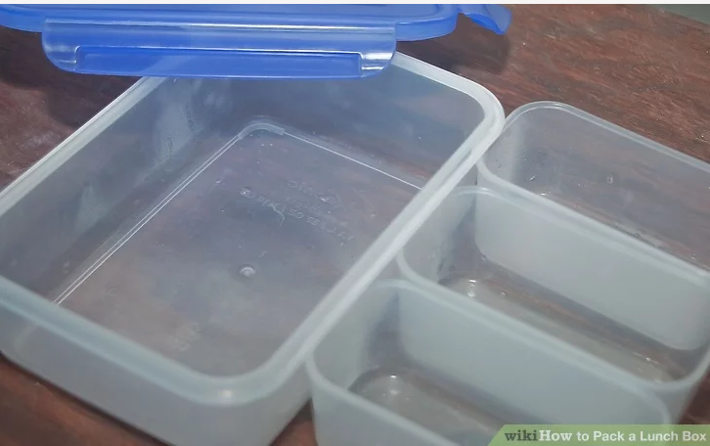

**1.Select a good lunch box.**

Besides your favorite color (or cartoon character) look for these characteristics:

Ample capacity, especially if you are packing food for an entire day and not just a lunch hour. Don't forget.

Insulation. With good insulation and a freezer pack to keep things cool, foods will be fresher at lunchtime. Wrap juice boxes in newspaper to keep them cold.

Carrying handles or straps. Try these in the shop, especially if you will carry your lunch box by hand a great deal, such as if you walk or cycle to school.

Easy cleanup. No matter how carefully you pack, your lunch box will end up with crumbs and spills in it, so think ,when you buy it, think about how easy it will be to wipe or rinse out.

**2.Prepare the day before what you want to have because if you don't have something you want, you can pop down to the shops.**

You can even plan your lunch menus a week ahead, if you like. Preparing your lunch the night before also means less time is wasted in the morning.

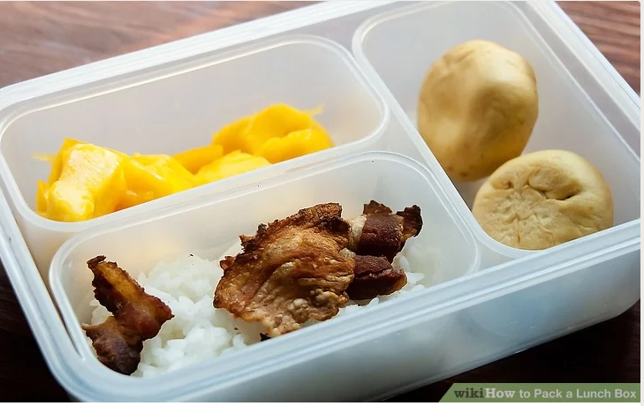

**3.Prepare the food.**

Aim for a variety each day. Try including:

A main dish, such as a [sandwich](https://www.wikihow.com/Make-a-Sandwich), [soup](https://www.wikihow.com/Make-Lentil-Soup), [salad](https://www.wikihow.com/Make-a-Salad), or [wrap](https://www.wikihow.com/Make-a-Pita-Wrap).

Fruit(s) and vegetables.

Snack(s) and treats.

A drink.

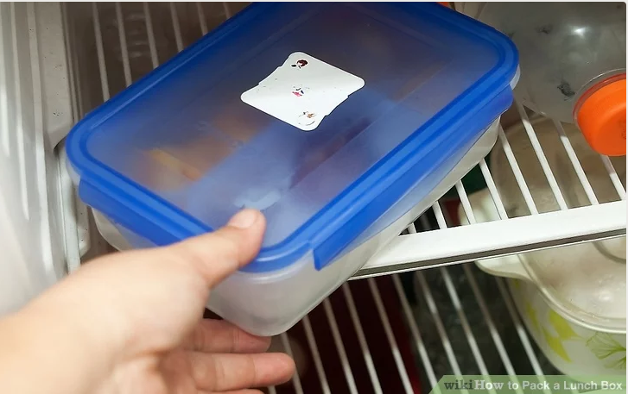

**4.Place your lunch box in the refrigerator once it is packed, to keep perishable items from spoiling.**